

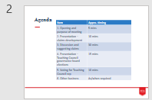

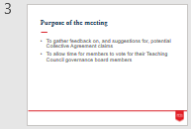 | The purpose of this meeting is to give you the opportunity to suggest claims for the new Collective Agreement. You will also be given time to take part in the Teaching Council governance board elections.
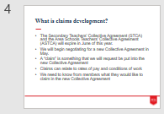 | The Collective Agreement sets pay and conditions for teachers. The current agreement comes to an end on 30 June 2022. This gives us the opportunity to bargain for new pay rates and changes to our conditions.  We will put together a number of “claims” for changes we want to see in the new Collective Agreement. We need to know what changes you would like us to claim.
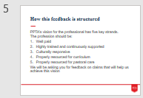 | The first phase of claims development took place last year, and it was to ask you about your vision for the teaching profession. The information that PPTA received can be summarised into five key headings. The profession should be:  - Well paid.  - Highly trained and continuously supported.  - Culturally responsive.  - Properly resourced for curriculum.  - Properly resourced for pastoral care.  The next step is to get your suggestions for what we need to claim in the Collective Agreement to work towards this vision.
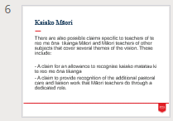 | In the process of developing this vision, PPTA identified significant extra workload that falls on teachers of te reo me ōna tikanga Māori. PPTA is seeking suggestions from these teachers as to claims that could help alleviate the heavier workload and provide renumeration for kaiako matatau ki te reo me ōna tikanga.
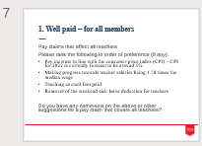 | The first part of the vision for the profession is that it should be well paid. This falls into two parts. The first is pay claims that will benefit all teachers. Please consider the suggestions listed and we will discuss which are our priorities. We will also discuss any other claims suggestions that are not listed here but we would like to put forward.  [Note for the speaker: at this point allow for discussion and make sure the order of preference and other suggestions are recorded in the minutes so you can fill in the digital form after the meeting.]
 | The second consideration is pay claims that will benefit certain groups of teachers. Please consider the suggestions listed and we will discuss which are our priorities. We will also discuss any other claims suggestions that are not listed here but we would like to put forward.  [Note for the speaker: at this point allow for discussion and make sure the order of preference and other suggestions are recorded in the minutes so you can fill in the digital form after the meeting.]
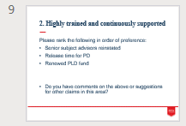 | The second part of the vision for the profession is that it should be highly trained and continuously supported. Please consider the suggestions listed and we will discuss which are our priorities. We will also discuss any other claims suggestions that are not listed here but we would like to put forward.  [Note for the speaker: at this point allow for discussion and make sure the order of preference and other suggestions are recorded in the minutes so you can fill in the digital form after the meeting.]
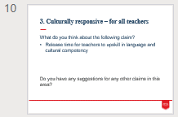 | The third part of the vision for the profession is that it should be culturally responsive. This has two parts. The first is measures that will apply to all teachers. Please consider the suggestion listed and we will discuss if this is a priority. We will also discuss any other claims suggestions that are not listed here but we would like to put forward.  [Note for the speaker: at this point allow for discussion and make sure the order of preference and other suggestions are recorded in the minutes so you can fill in the digital form after the meeting.]
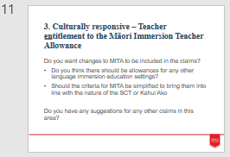 | The other consideration is about entitlement to the Māori Immersion Teacher Allowance. Please consider the suggestions listed and we will discuss if these are a priority. We will also discuss any other claims suggestions that are not listed here but we would like to put forward.  [Note for the speaker: at this point allow for discussion and make sure the order of preference and other suggestions are recorded in the minutes so you can fill in the digital form after the meeting.]
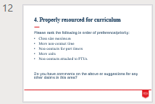 | The fourth part of the vision for the profession is that it should be properly resourced for curriculum. Please consider the suggestions listed and we will discuss which are our priorities. We will also discuss any other claims suggestions that are not listed here but we would like to put forward.  [Note for the speaker: at this point allow for discussion and make sure the order of preference and other suggestions are recorded in the minutes so you can fill in the digital form after the meeting.]
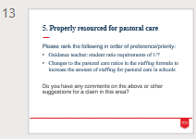 | The fifth part of the vision for the profession is that it should be properly resourced for pastoral care. Please consider the suggestions listed and we will discuss which are our priorities. We will also discuss any other claims suggestions that are not listed here but we would like to put forward.  [Note for the speaker: at this point allow for discussion and make sure the order of preference and other suggestions are recorded in the minutes so you can fill in the digital form after the meeting.]
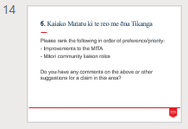 | This section is specifically targeted at kaiako matatu ki te reo me ōna tikanga. Please consider the suggestions listed and we will discuss which are priorities. Please also provide other claims suggestions that are not listed here but we would like to put forward.  [Note for the speaker: at this point allow for discussion and make sure the order of preference and other suggestions are recorded in the minutes so you can fill in the digital form after the meeting.]
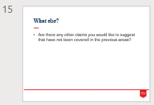 | Do you have any other suggestions for claims that haven’t come up yet?  [Note for the speaker: at this point allow for discussion and note any suggestions so you can fill in the digital form after the meeting.]
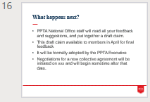 | I will fill out the survey monkey with your preferences and suggestions and send it through to PPTA national office.  They will use our feedback to put together a draft set of claims. This will then go to the Executive Committee for approval and then it will go out to members for final feedback.  Pre-bargaining between the Accord members (the Ministry of Education, NZEI and PPTA) will begin in March and bargaining itself starts at the end of April.
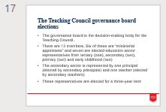 | The Teaching Council governance board elections are taking place at the moment. If you have not already voted we would like to give you this time to do so.  The governance board is the decision making body for the Teaching Council. There are 13 members. Six of these are “ministerial appointees” and seven are elected education sector representatives from tertiary, secondary, primary and early childhood sectors.  The secondary sector is represented by one principal (elected by secondary principals) and one teacher (elected by secondary teachers)  These representatives are elected for a three-year term.
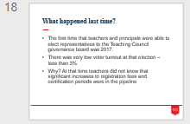 | This is only the second time we have been able to vote for board members. The first time that teachers and principals were able to elect representatives to the Teaching Council governance board was 2017.  There was very low voter turnout at that election – less than 3%.  At that time teachers did not know that significant increases to registration fees and certification periods were in the pipeline. In addition, online elections always have significantly lower turnout than paper elections – especially for busy teachers with swamped email inboxes.
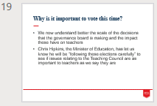 | After the fees increase, the change to annual certification, the judicial review, and most recently the data breach, the relationship between the Teaching Council and the profession is strained to breaking point.  We now better understand the scale of the decisions that the governance board is making and the impact these have on teachers.  Chris Hipkins, the Minister of Education, has let us know he will be “following these elections carefully” to see if issues relating to the Teaching Council are as important to teachers as we say they are.
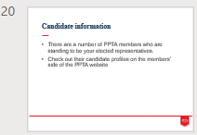 | There are a number of PPTA members who are standing to be your elected representatives.  Check out their candidate profiles on the members’ side of the PPTA website.  [Note to presenters: have this information up on the screen if you can.]
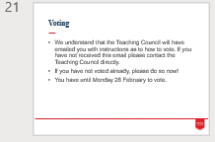 | The Teaching Council will have emailed you with instructions as to how to vote. If you have not received this email please contact the Teaching Council directly.  If you have not voted already, please take advantage of this time to do so now.  If you want some more time to consider the information, you have until Monday 28 February to vote.


