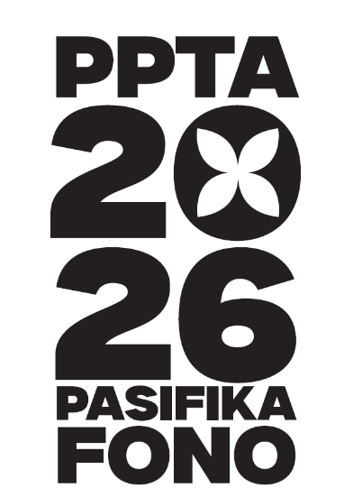


PPTA Fono 2026: The Niu Generation – Presentation Guide
To apply to present at Fono click here.
Why should you present at Fono?
Our delegates want to hear great ideas from the profession – at the chalkface so to speak.
Sharing your good practice, or your innovative ideas, is extremely good professional development. It’s also a really great way to network with your peers.
We value your time and expertise. If your presentation brief is accepted, we will cover your costs to attend. This includes Fono registration, travel costs, and accommodation at the Fono venue.
Applications must be received by March 20th
What are we looking for?
- Teacher practice that has made a difference in your classroom – for Pasifika students especially.
- School initiatives that have seen improvement in any of the MoE focus areas – attendance, academic, pastoral
- Resources to share
- Research you’ve conducted – either through a formal academic pathway or less formal, such as through Kahui Ako or other in-school professional learning
- Ideas and calls-to-action
- Anything you want to share with your fellow kaiako
Writing a workshop abstract
Our workshop format is 45 minutes or 90 minutes
Your presentation can be:
- A hands-on workshop with ‘active’ learning
- A ‘chalk’n’talk’ presentation
- A feedback session – presenting information and asking for feedback and suggestions
- A mixture of the above
- Anything else
The abstract is used to help the organising committee build the programme and will also be used in the Fono programme.
Just like a unit or lesson plan, you’ll want to consider the intended outcomes of your presentation. What do you want delegates to know or have done when they leave your session?
Consider who you think will benefit most from your presentation? Early career teachers? Middle-Leaders? When developing your abstract consider how you will encourage these people to attend?
You can present solo, in pairs, or a group. You can also choose whether you want to present once or twice through the programme. See the application form for more information.
Presentation Tips
While similar to teaching, presenting to adults often makes us feel way more nervous!
Similarly to how you craft a lesson plan, providing an overview of your presentation at the beginning helps set the tone and expectations for the delegates.
Keep your visuals clean and simple – avoid ‘death by PowerPoint’ where you are simply reading your slides. If you want to read notes, have them printed out or use presentation mode.
Rehearse and practice your timing before you present. There’s nothing worse than being told you have five minutes to go when you know you have half your presentation left! It’s also good practice to keep questions until the end. If your workshop is more hands on you need to make sure you’ve allowed enough time if you are inviting discussion.
It can be worthwhile having some extra questions for your audience if you end up with extra time at the end. They can become ‘rhetorical’ if you don’t need them – something for your audience to muse on through the rest of the Fono (and beyond).
Consider including a QR code with your contact details, or business cards so that delegates can contact you afterwards.
Presentation Requirements
Please submit a copy of your presentation no later than the day before your workshop. It’s always good to have a backup as well.
Please include your contact details and any resources that you wish to provide to delegates. After the Fono we will send out links to all the presentations.
Arrive in the room at least 10 minutes before you are presenting. If you are the second presenter in a session you should check in before the beginning of the session.
What we Provide
$100 reimbursement towards materials for your workshop.
Support and guidance leading up to the Fono.
Technical support on-site
A prize for a member of your audience. It’s up to you how you give it away. It could be best question, best response, or completely random!

